**Day3 - Assignment 2:**

Produce a comparative infographic of TDD, BDD, and FDD methodologies. Illustrate their unique approaches, benefits, and suitability for different software development contexts. Use visuals to enhance understanding.

1. **Test-Driven Development (TDD)**

TDD focuses on unit testing and code quality.

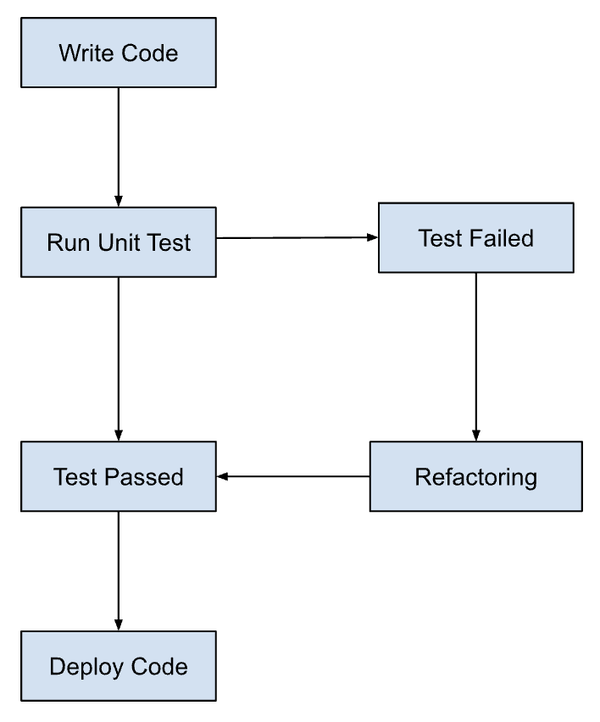

Approach:

* Write tests before writing functional code.
* Tests drive the design and implementation.

Benefits:

* Early detection of defects.
* Improved code quality.
* Promotes modular design.

Suitability:

* + Agile environments.
  + Iterative development.
  + Complex projects needing thorough testin

1. **Behaviour-Driven Development (BDD)**

BDD emphasizes behaviour and collaboration.

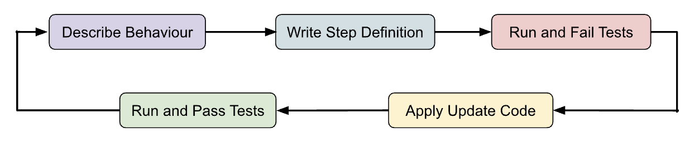

Approach:

* + Define behaviour using scenarios and examples (Given-When-Then format).
  + Focus on user stories and acceptance criteria.

Benefits:

* + Improved communication between stakeholders.
  + Encourages collaboration (developers, testers, business analysts).
  + Tests aligned with business goals.

Suitability:

* + Customer-focused applications.
  + Cross-functional teams.
  + Projects emphasizing user experience.

1. **Feature-Driven Development (FDD)**

FDD is structured around features and team scalability.

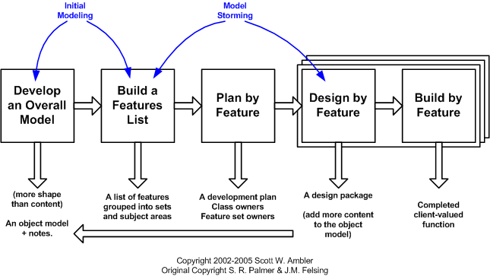

Approach:

* + Iterative and incremental development.
  + Emphasizes feature breakdown and scheduling.

Benefits:

* + Clear feature ownership.
  + Structured development process.
  + Scalable for large teams.

Suitability:

* + Large-scale projects.
  + Enterprise applications.
  + Projects with defined feature sets.